User Manual for Admin

1) For new admins, they can enter using the credentials of Aidyn (login: [aidyn@gmail.com](mailto:aidyn@gmail.com) and password: asd).

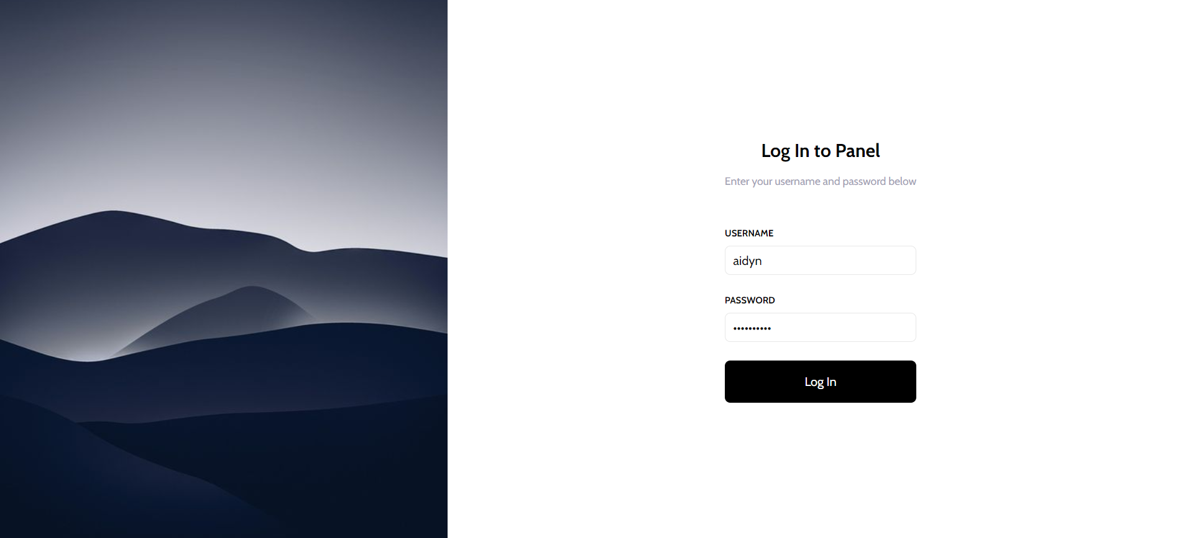

2) Next, they are redirected to the main page with new appointments. On the left there is a navigation bar to help the administrator orient himself in the system.

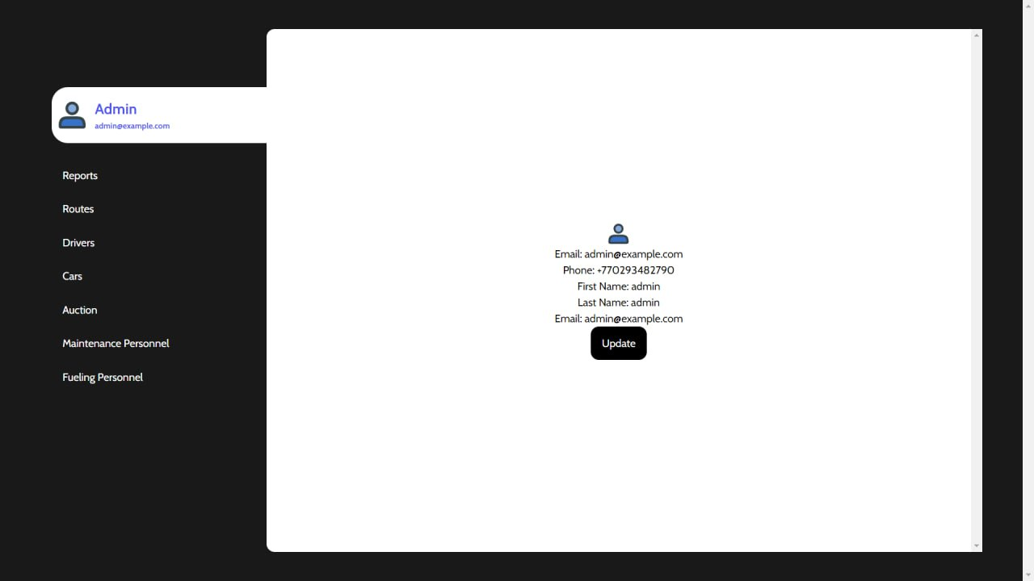

3) On this Appointment page the administrator can see all the inactive and active routes that drivers do. In addition, he can add new appointments and provided needed information to it.

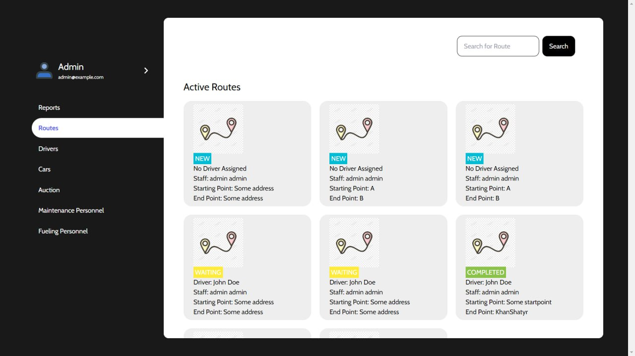

4) Now, the administrator can view all the drivers with contact information in case of an emergency. He can add new drivers to the system, just as in the case of appointments.

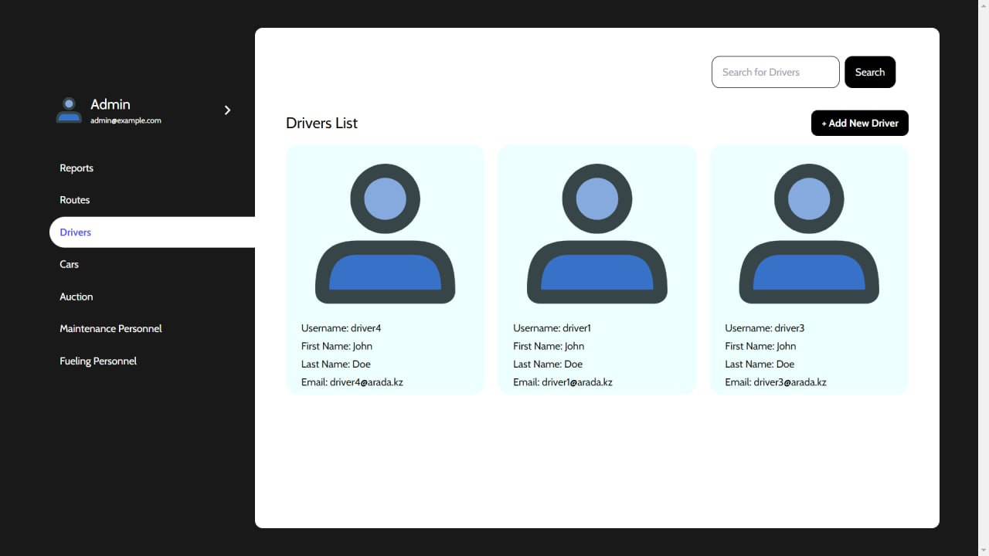

5) The same applies to the Cars page, where just by clicking the Add New Car button the administrator can update the database.

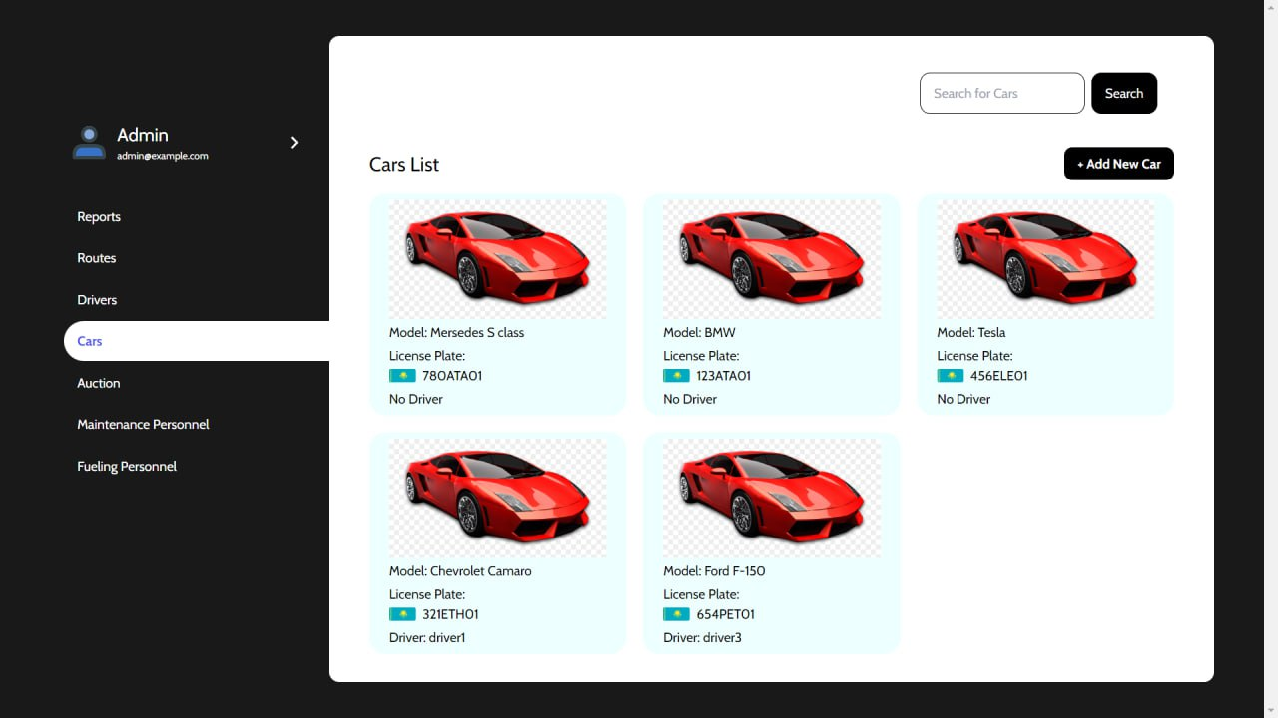

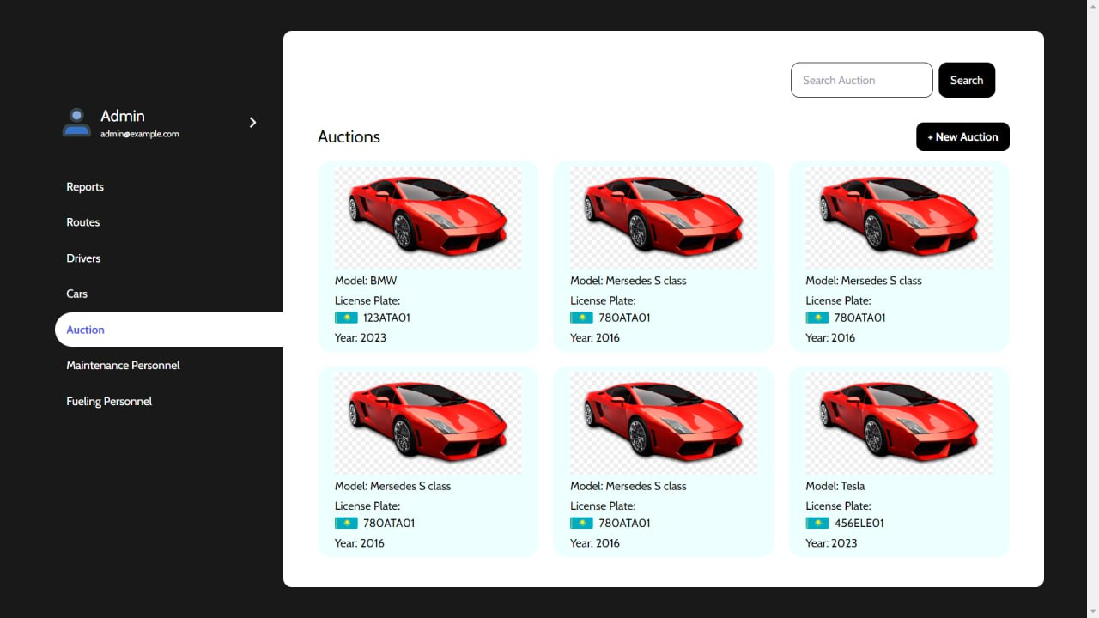

6) The same functionality applies to both Maintenance and Fueling Person pages. 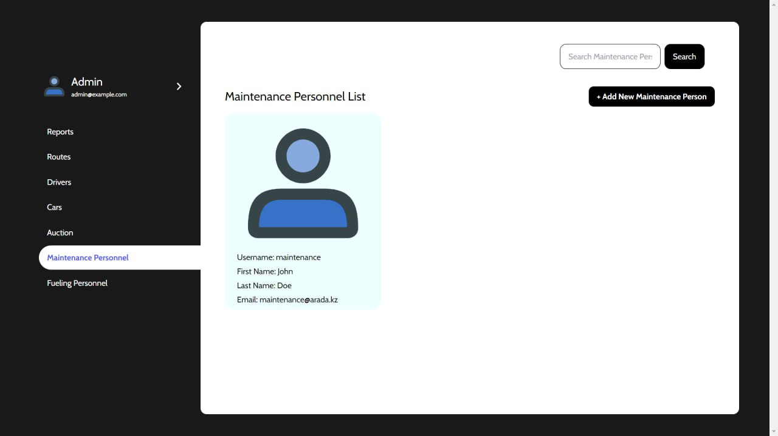

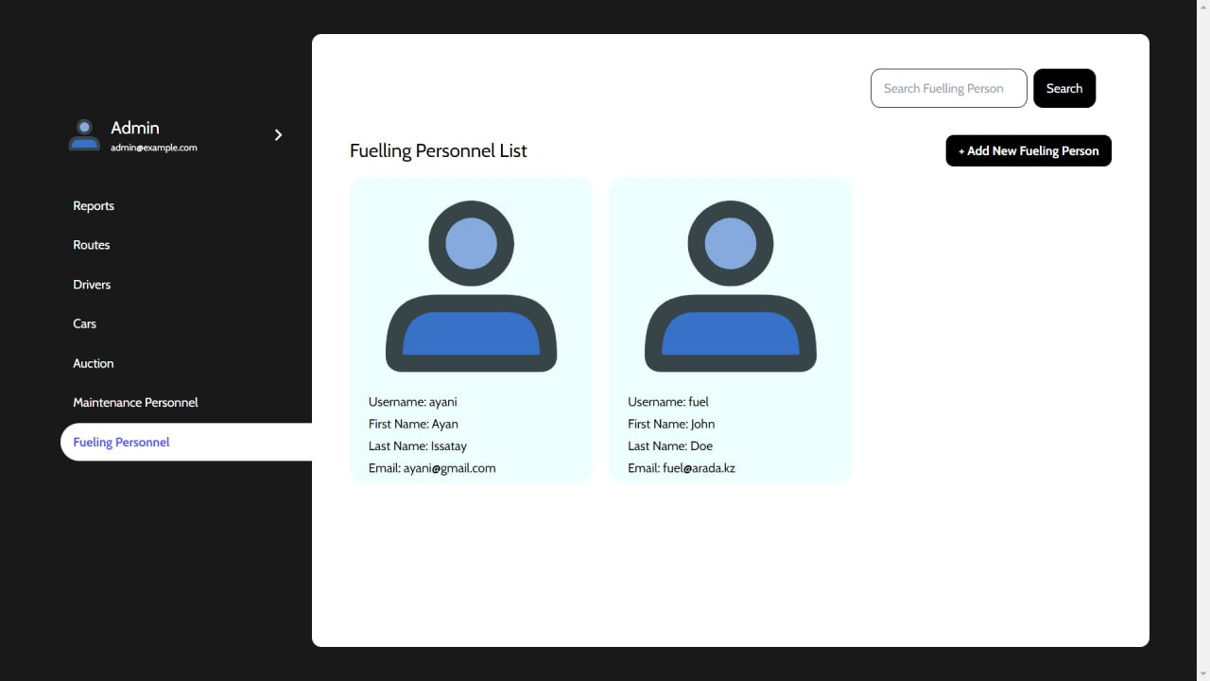

Application User Manual

1) First, the user sees the login page and needs to enter the correct credentials to enter the system. If the user does not have an account he should contact the admins first.

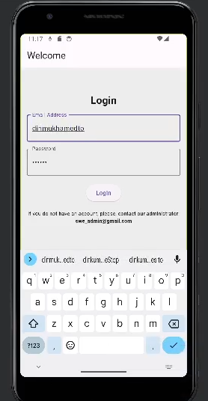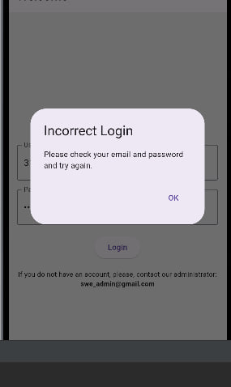

2) If he or she needs to contact the administrator using the provided email and provide all the relevant information for him.

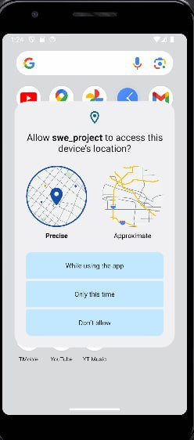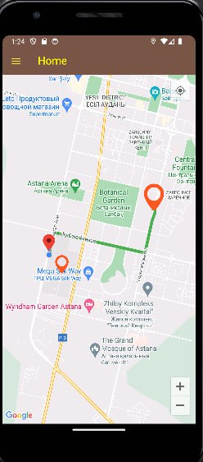

3) User if logged in successfully, enters the Main Page with his location shown on the map. There, if he has some appointments or tasks, he will see flags on the map, and a path from his current location to the destination.

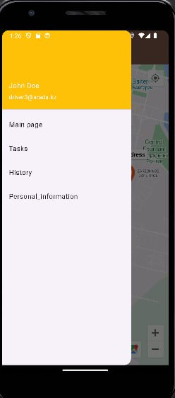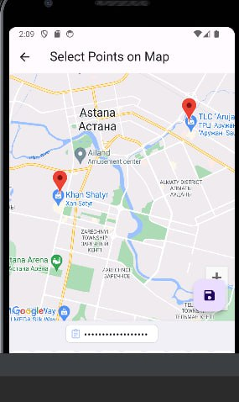

4) If the user clicks on the button at the top right corner, the map will show his current location. The app will ask whether you give your consent to track your location.

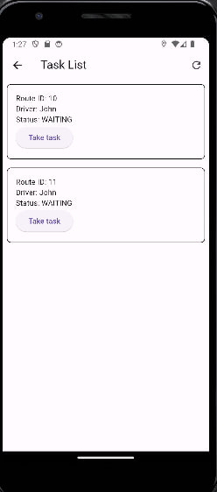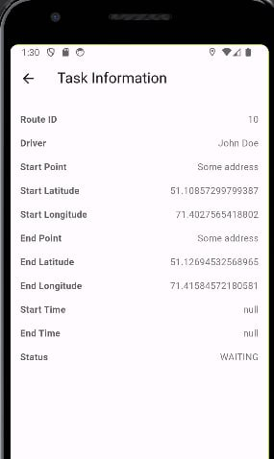

5) Users can explore pages using the sandwich menu at the top left corner. Click on the page that you want to navigate.

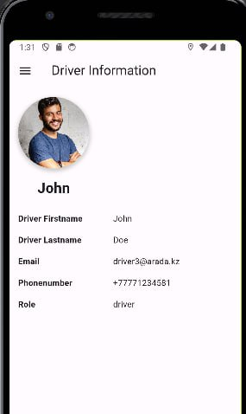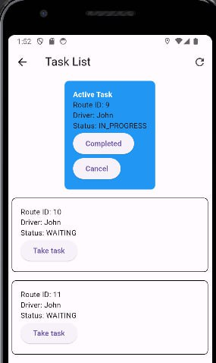

6) Driver information will show the user information.

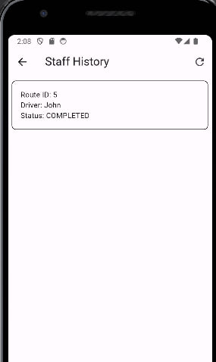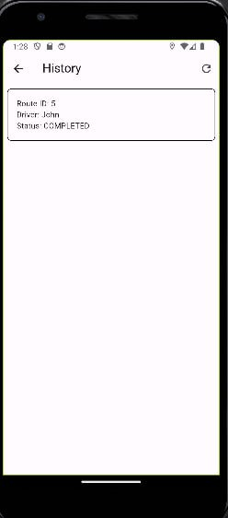

7)The driving history will show all tasks accomplished by the user (Still in progress).

8)The current task will show all tasks assigned to the user.